Final project

Object Oriented Programming

Bank stimulation

# Submitted by

[Mujtaba Ahmed]

SP20-BSE-079

[Umair Arshad]

SP20-BSE-097

[Zeeshan Fareed]

SP20-BSE-101

# Github link

<https://github.com/zeeshanfareed76/OOP-Project>

# Introduction

Our Project stimulates a bank's working on 2 entities i.e.

-ACCOUNTS-

-EMPLOYEES-

They both have following in common:

* Personal details

1. Name
2. Phone Number
3. Address

For which we used a base class "Person" and derived 2 classes from it.

An account has the following attributes:

-Account Number

-Balance

An Employee has the following attributes:

-Employee Id

-Designation

-Salary

Then we have 2 classes

-AccountList

-EmployeeList

Which are used to store data regarding both entities,

AccountList works out different tasks performed on an Account and interreacts with a file named “Accounts”

EmployeeList works out different tasks performed on an Employee and interreacts with a file named “Employee List”

It implements following OOP Concepts

-Classes

-Inheritance

-Encapsulation

-Polymorphism

-Interface

-Array List

-Exceptions

-File Handling

# AvailAble Entities to work on

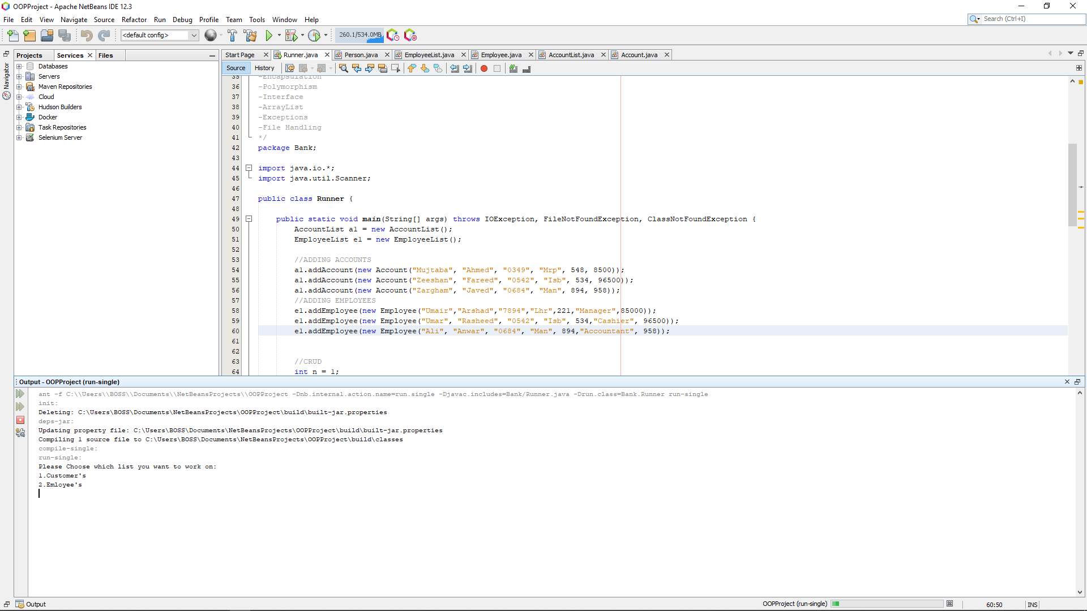

1.This software is designed to be used by Employees of Bank. User can Work on Customer entity or Employee Entity.

# MAin Menu of Customer Entity

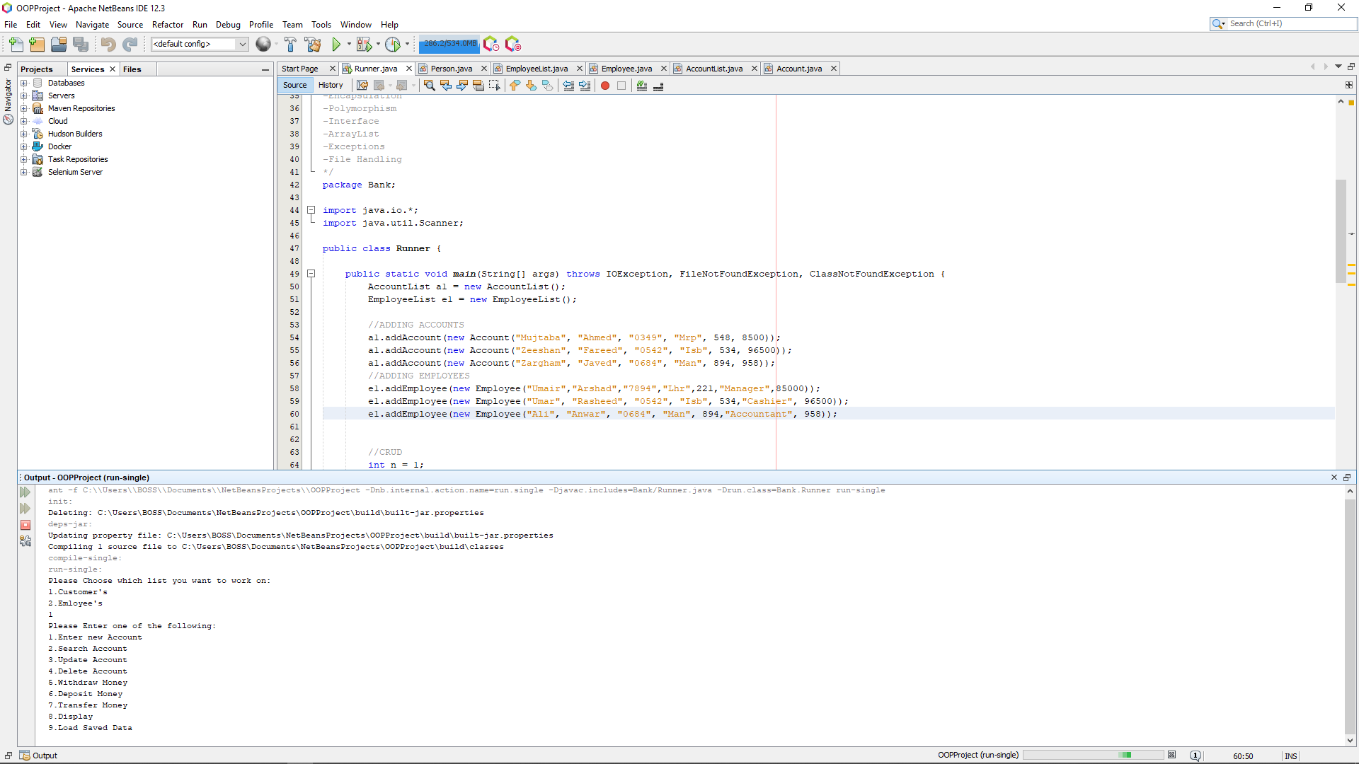

2. Main Menu of Customer Entity

# MAin Menu of Employee Entity

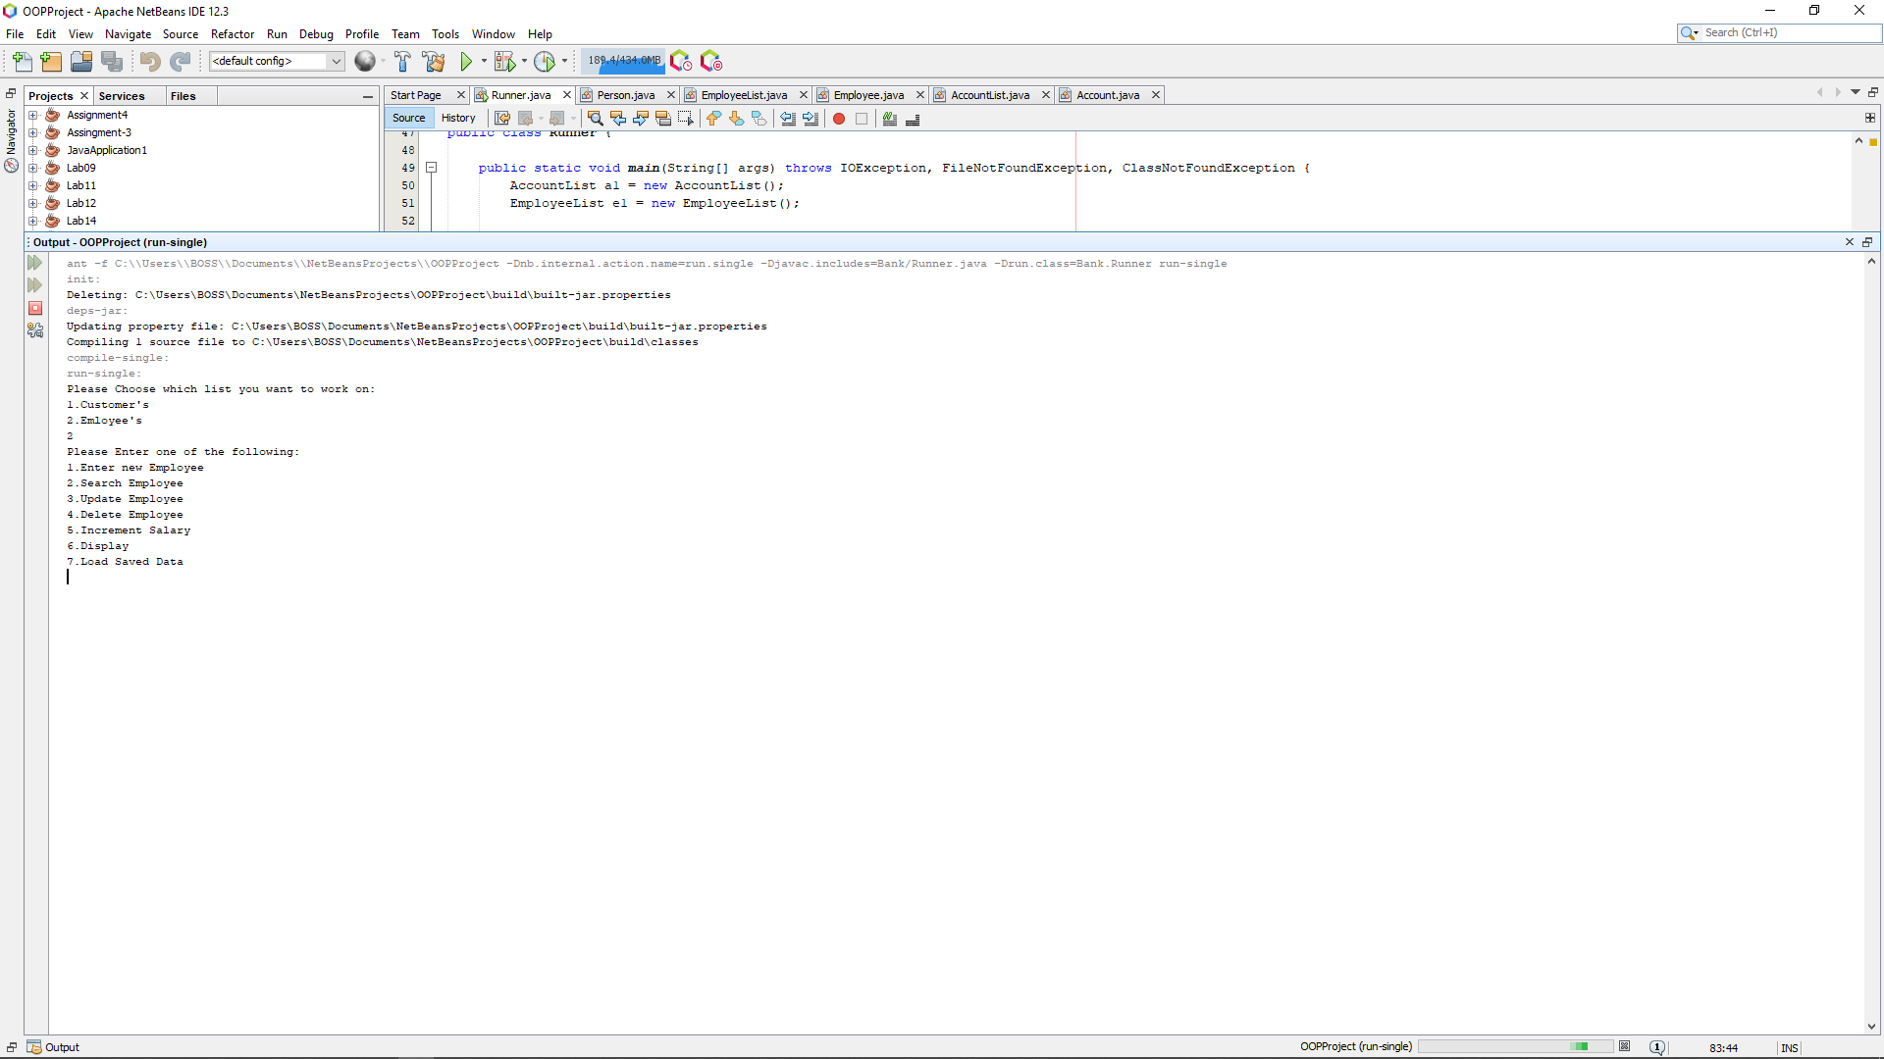

3. Main Menu of Employee Entity

# Creating new Customer Account

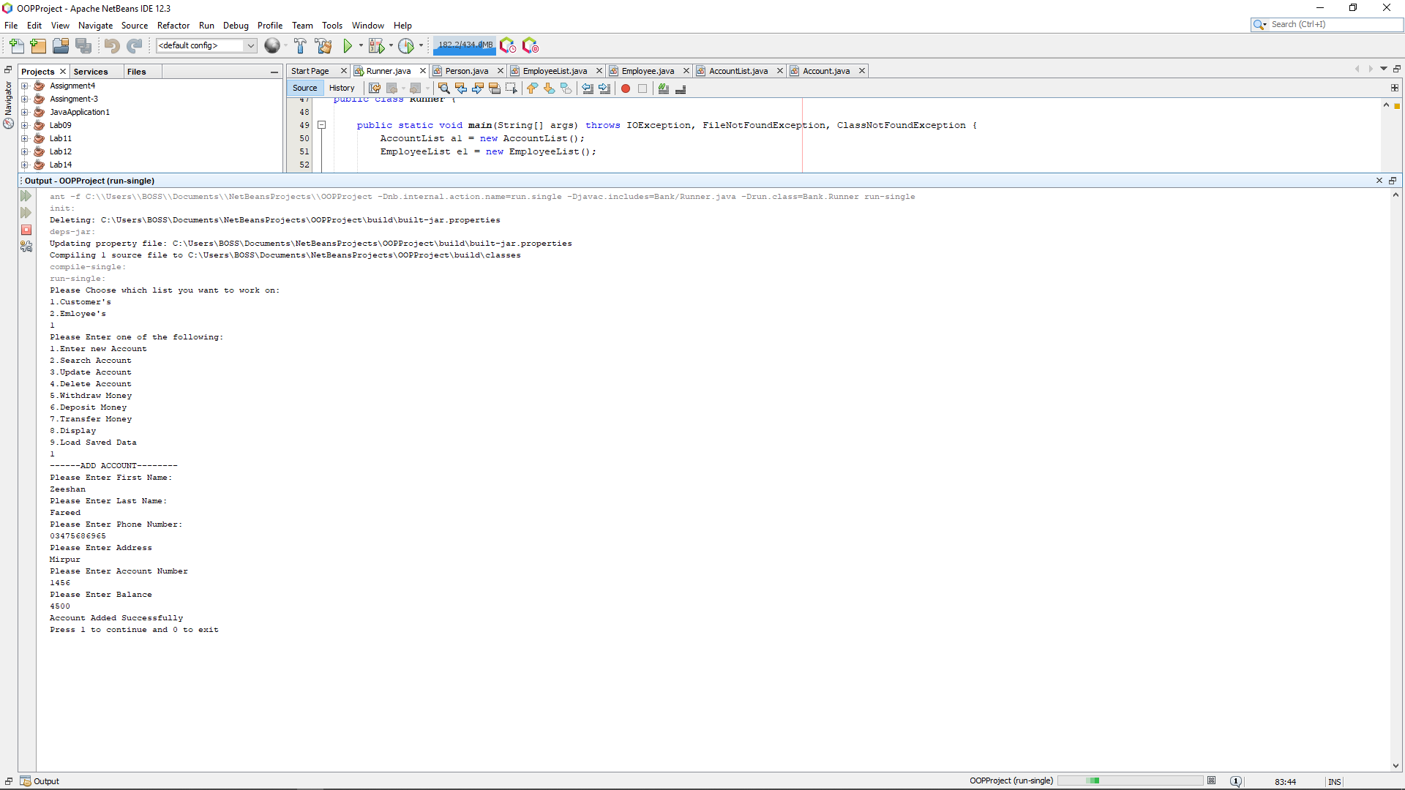

4. New Customer Account Created

# search contact

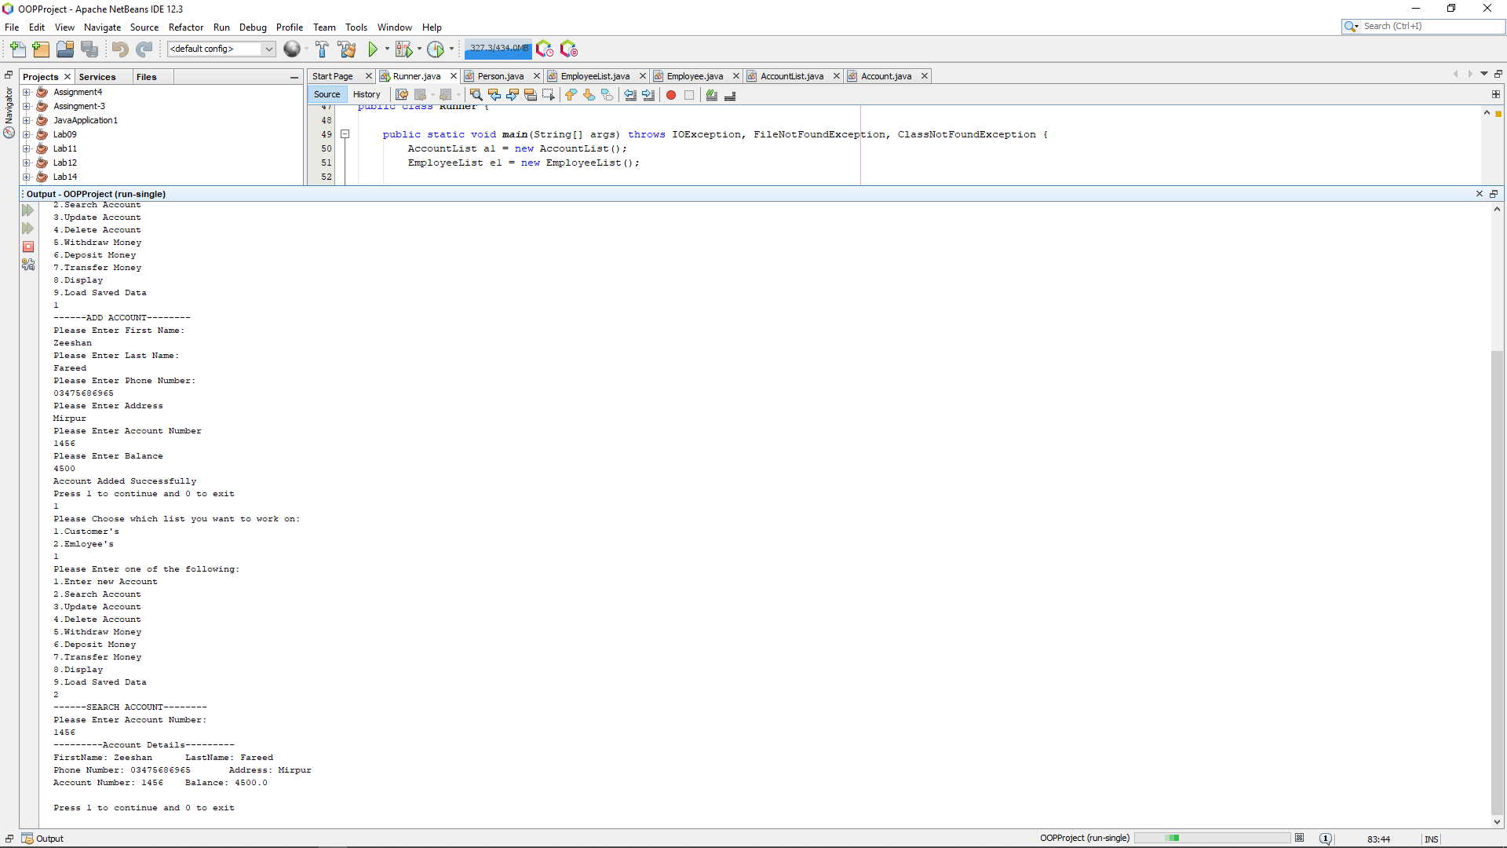

. Searching Customer Account

# Transferring Money From One Account to Another

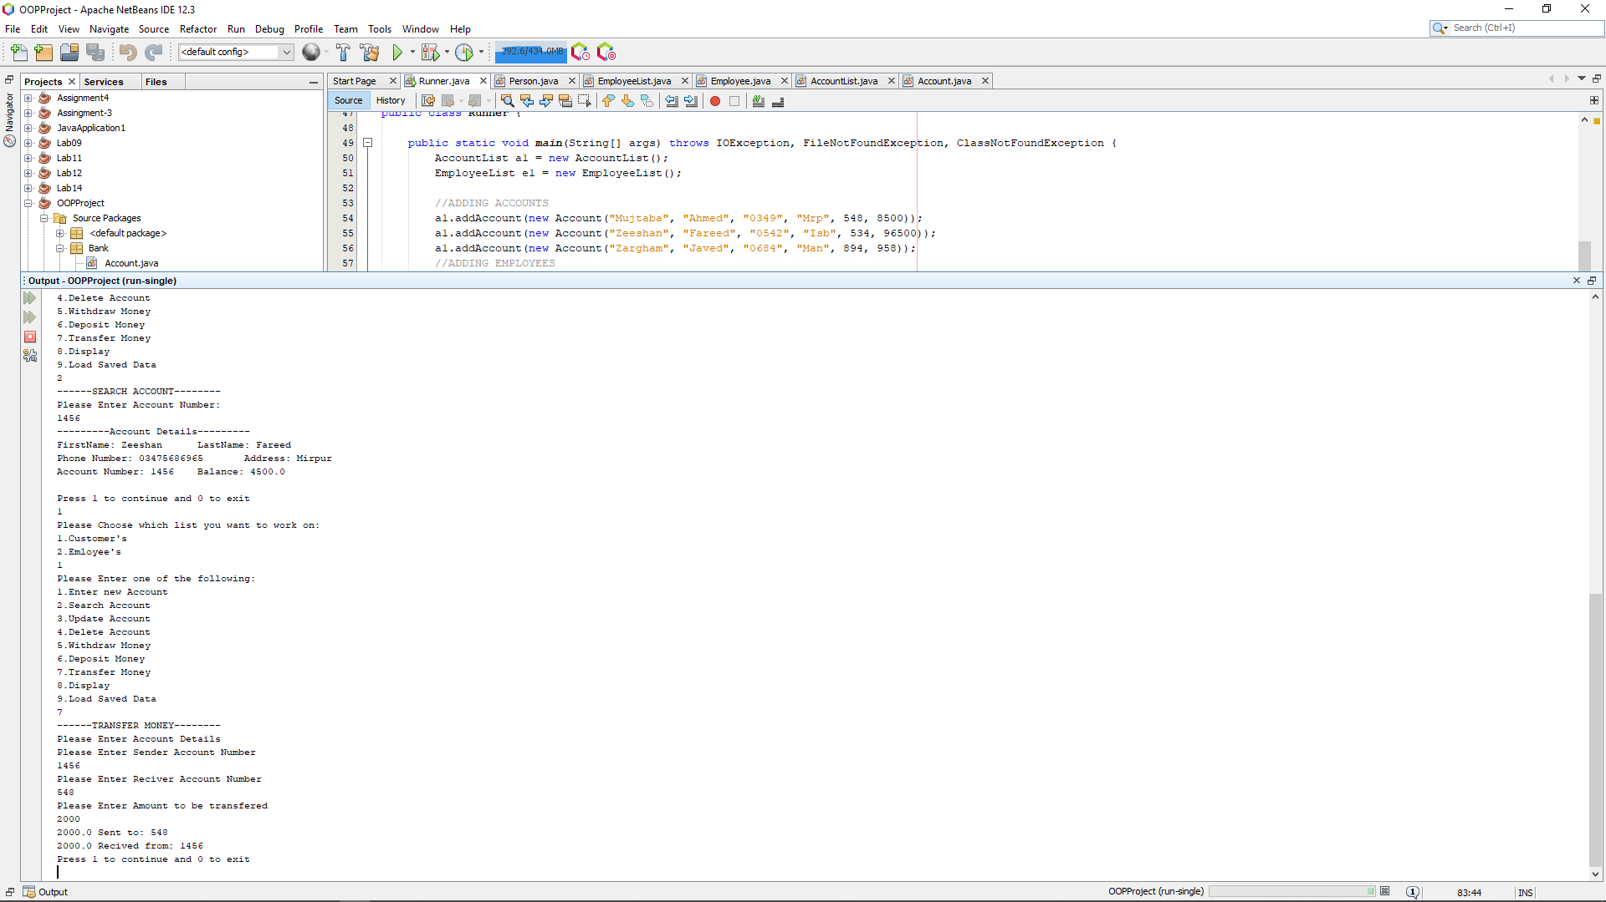

6. Money Transferred from one Account to Another

# Displaying All customers accounts

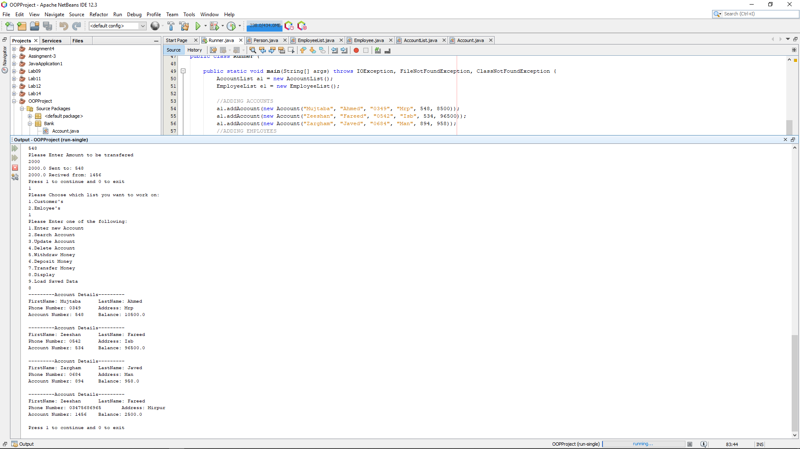

7. All Customers Accounts Being Displayed